APP DEV AND EMERGING TECHs

Jericho Bruce Rivero | BSIT

Activity 5

1. There are 5 vowels in English alphabets, these are “**a**”, “**e**”, “**i**”, “**o**” and “**u**”.

Write a Python program that will determine the given data below if it is Vowels or Consonants. Display all at once.

Given Letters:

1. b
2. e
3. q
4. o
5. i

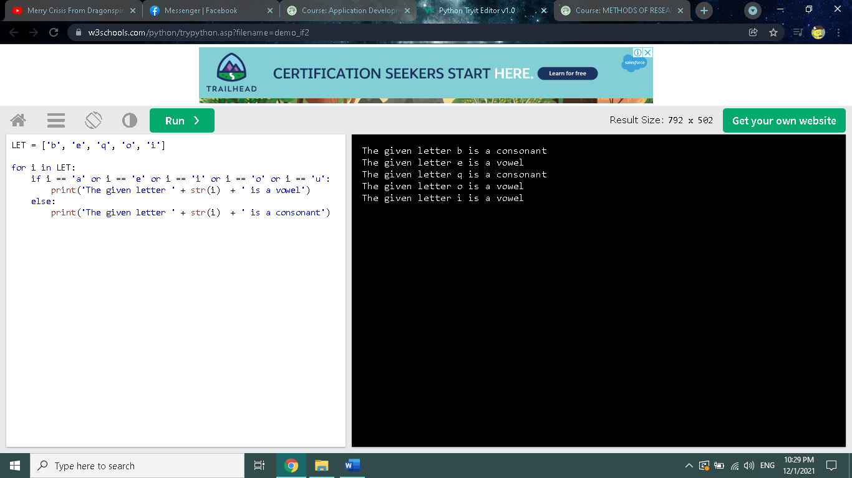

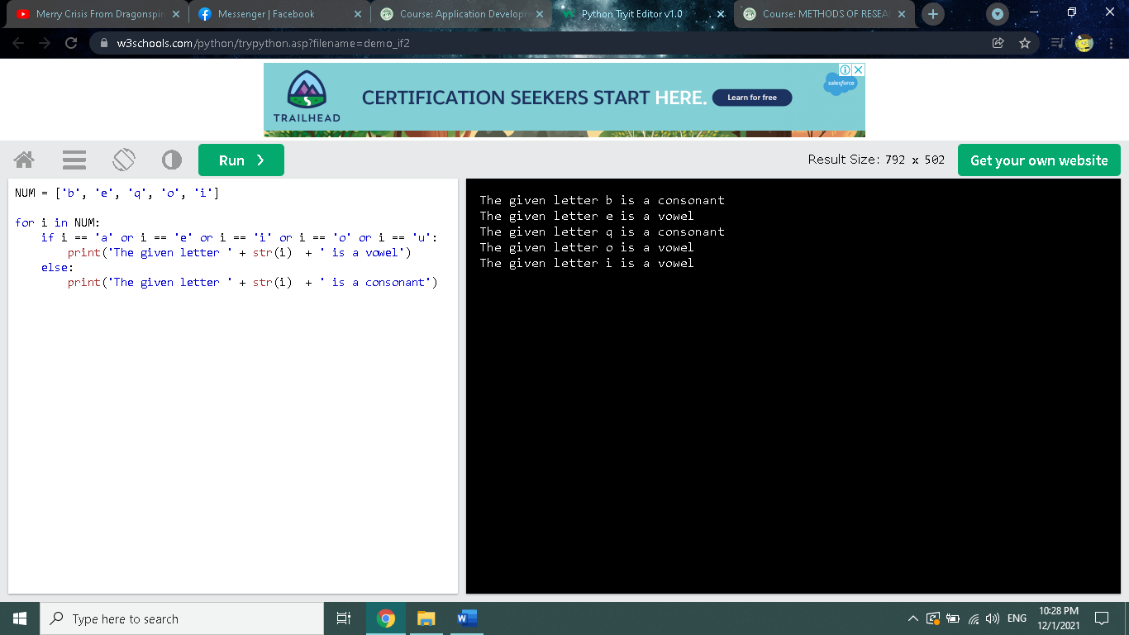

LET = ['b', 'e', 'q', 'o', 'i']

for i in LET:

if i == 'a' or i == 'e' or i == 'i' or i == 'o' or i == 'u':

print('The given letter ' + str(i) + ' is a vowel')

else:

print('The given letter ' + str(i) + ' is a consonant')